Task 1-Granularity 3

Task 2 – Star Schema 4

Task 3-Data warehouse 4

# **Task 1-Granularity**

Granularity plays a vital role in the overall design process of a data warehouse. Granularity implies the level of detail of your data within the fact or dimension tables.

In a typical data warehouse, a fact is usually designed at a low level of granularity in order to provide detailed facts which can be drilled down or sliced across all dimensions in order to generate higher level of facts.

Fact tables can store detailed data such as sales price of a product or aggregated data such as total sales of a week. The higher the granularity of a fact table the more data it will store. Granularity also determines the kind of information which can be retrieved from the stored data.

A weekly report can only be generated when you have time related data stored at least with a granularity of week or the day is even better which can also helpful to generate daily sales report.

In our use case of Omni benchmark data warehouse design, all the questions required the total sales on year, month, week and day basis which clearly states that we need to store our sales with day granularity in the fact table.

In order to generate daily reports facts must be present with finer granularity at least date level granularity is required. If the facts are stored at higher granularity such as week, month or year basis then the daily report of total sales won’t be possible to retrieve. So in our design, we’re choosing to keep all the sales facts on date level in our Sales_Fact table. For generating the reports on higher granularity like week or month, date dimension can be used.

# **Task 2 – Star Schema**

Star schema of the data warehouse is presented below which contains a fact table namely Sales_Fact and four dimensions.

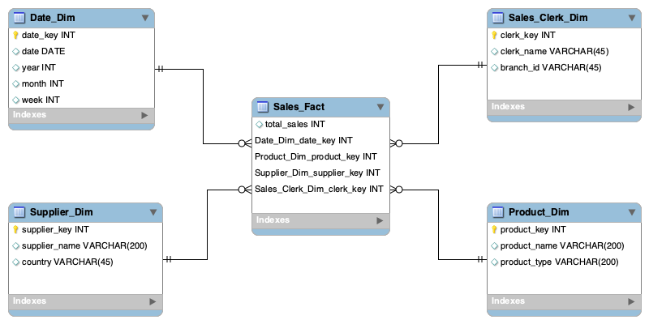

# **Task 3-Data warehouse**

Granted privilege to the account ICT394TL to view the structure of my data warehouse, to access my records..



